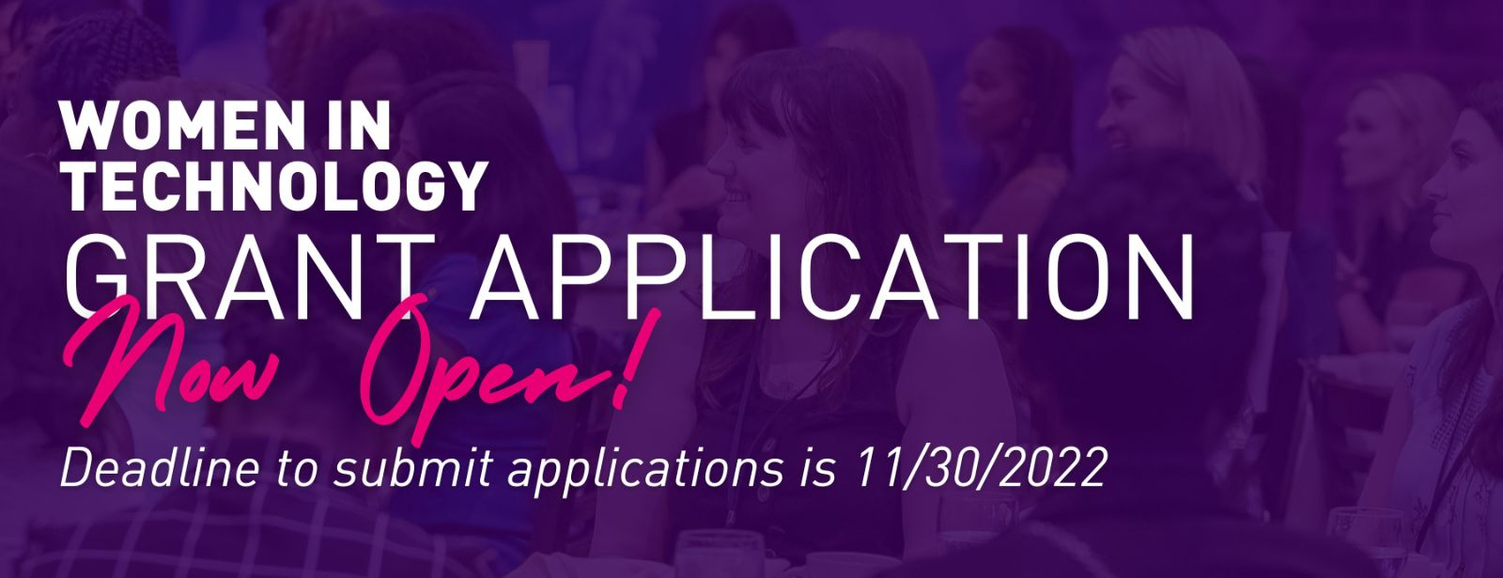
WIT Grant Application

To be considered for a grant, your organization must meet the following criteria:
- Non-profit corporation with 501(c)(3) tax status as declared by the IRS (within the state of Georgia)
- Must have a Board of Directors
- Must serve economically disadvantaged students (Elementary and/or Middle School grade levels) with programs dedicated to empowering girls to excel in STEAM through the use of technology
- Primary clients must be at least 50% girls (Elementary or Middle school grade level)
- Applicants may only apply for program grants
- Grant awards will be in the range of $500 - $5,000
Submission Deadlines
- Deadline to submit applications is 11/30/2022
Authorized Contact Phone:
Year founded:
EIN Number:
CEO or Executive Directors name:
CEO or Exec Director Email:
CEO or Exec Director Phone Number:
Street Address:
City:
State:
Organization Website:

Organization Social Media Handles:

Mission Statement:
Total Current Operating Budget:

Applicant Signature:

Primary Source of Funds:

Program Title:

Purpose of Grant Request:

Impact of Grant Request:

Program Focus Areas:
Science
Technology
Engineering
Arts
Math
Program Focus Area(s) Description:
Grant Amount Requested:
Total Program Cost:
Numbers Served By Program:
Program Time Period:

Sustainability Plans:

Major Commitments:

Sources of Other Funds to Support Program:

Program Target Population:

Race Ethnicity Served:
African American or Black
Asian or Pacific Islander
Latino
White
Native American or American Indian
Other
Unknown

Race/Ethnicities selected above (list numbers &amp;amp;amp;amp;amp;amp;amp;amp; percentages):

Age Groups:
0-5 years
6-10 years
11-15 years

County Served:
Cherokee
Clayton
Cobb
Dekalb
Douglas
Fayette
Forsyth
Fulton
Gwinnett
Hall
Henry
Rockdale
Other County
If you selected Other County please specify:

Provide state(s) in which your program serves:
Percentage of female students in target population:

Supporting Documents

IRS letter confirming 501C3 status (File Upload):

Current Board of Directors - Names (President Vice-President Secretary Treasurer or Member At La:

Please list your Leadership Staff and their Titles:

Board Approved Budget for Current Fiscal Year (File Upload):

Program proposed and past measures of success:

Program Budget: Program funds secured to date - funder(s) and amount(s):

Brief summary of organization’s history goals and key achievements [1 page Max]:

Narrative describing how your program can have a positive impact on female students and their interests:

Summary of marketing/PR tools in place to give visibility to WIT’s support of your program; methods:

Additional Materials (File Upload):

